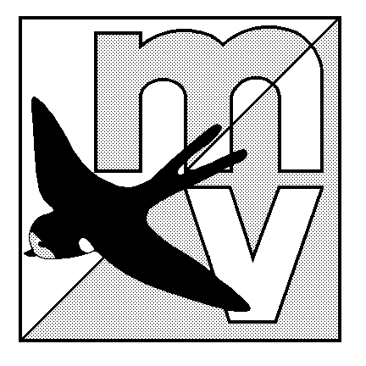MOLE VALLEY ORIENTEERING CLUB
(affiliated to the British Orienteering Federation)

Evening Score Event

The Nower, Dorking
Tuesday 17th June 2008

Venue: Small but interesting area of mostly runnable woodland, with many paths.

Car Park: Milton Heath car park - Grid Ref TQ154488. From Dorking town centre, follow the A25 (Westcott Road) towards Guildford. After approx. 500m turn off left (signposted ‘Bury Hill Fishery’) and the car-park (with 6’ 7’’ height restriction!) is a further 150m on the left. If coming from Guildford direction, go through Westcott and past the signed entrance to ‘Unum’ - as you come over the brow of the hill, the turning (signposted ‘Bury Hill Fishery’) will be approx. 200m on your right.

Map: 1:5000, 5m contours, A4 size - maps will be overprinted but not bagged.

Registration: 6.45pm - 7.30pm Courses close: 8.30pm
& Starts

Format: 1 Hour Score Event, with Map Exchange. Each map consists of 15 controls
with varying points values (5 low, 5 medium and 5 high). Decide how many controls you wish to visit on the first map, before returning to the Start to pick up a second map. Can you visit all 30 controls in the 1 hour time limit? A penalty of -10 points applies to each minute, or part thereof, over the 1 hour.

The event will be using SportIdent electronic punching (hire charge £1).

Fees: Seniors £2.00, Juniors Free

Facilities: Squash; no toilets. Dogs welcome.

Officials: Organiser / Planner - Neil Lewer (07878 722256)

MV Website: http://www.mvoc.org/ for results

Safety: Whistles recommended. Whilst all control sites have been visited with bare legs, full leg cover is recommended in case you decide to wade through some of the bracken!

IN THE INTEREST OF SAFETY ALL COMPETITORS MUST REPORT TO DOWNLOAD
Competitors participate in this event at their own risk

